3. Practice SQL Definition Language (DDL) Commands
3.1. Table creation and alteration
1. Create all 5 tables based on the schema provided.
Table Name: Departments
Column Name | Data Type | Constraints
Dept_ID | VARCHAR2(4) | PRIMARY KEY, starts with 'D'
Dept_Name | VARCHAR2(50) | NOT NULL, UNIQUE
Building | VARCHAR2(30)
Number_of_Classrooms | NUMBER(3) | CHECK(Number_of_Classrooms >= 0)
CODE:
CREATE TABLE Departments (
Dept_ID VARCHAR2(4) PRIMARY KEY CHECK (Dept_ID LIKE 'D%'),
Dept_Name VARCHAR2(50) NOT NULL UNIQUE,
Building VARCHAR2(30),
Number_of_Classrooms NUMBER(3) CHECK (Number_of_Classrooms >= 0) );
OUTPUT:
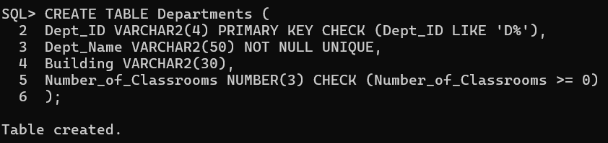

Table Name: Professors
Column Name | Data Type | Constraints
Prof_ID | VARCHAR2(5) | PRIMARY KEY, starts with 'P'
Prof_Name | VARCHAR2(50) | NOT NULL
Dept_ID | VARCHAR2(4) | FOREIGN KEY REFERENCES Departments(Dept_ID)
Experience_Years | NUMBER(2) | CHECK (Experience_Years >= 0)
CODE:
CREATE TABLE Professors
(Prof_ID VARCHAR2(5) PRIMARY KEY CHECK(Prof_ID LIKE 'P%'),
Prof_Name VARCHAR2(50) NOT NULL ,
Dept_ID VARCHAR2(4) REFERENCES Departments(Dept_ID),
Experience_Years NUMBER(2) CHECK(Experience_Years>=0) );
OUTPUT:
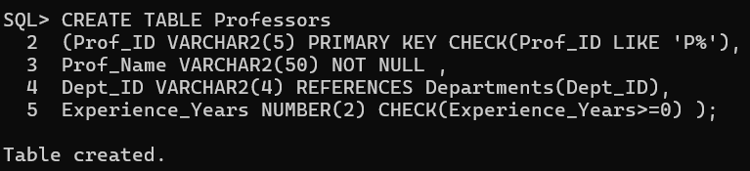

Table Name: Courses
Column Name | Data Type | Constraints
Course_ID | VARCHAR2(6) | PRIMARY KEY
Course_Name | VARCHAR2(100) | NOT NULL
Dept_ID | VARCHAR2(4) | FOREIGN KEY REFERENCES Departments(Dept_ID)
Prof_ID | VARCHAR2(5) | FOREIGN KEY REFERENCES Professors(Prof_ID)
Credits | NUMBER(1) | CHECK (Credits BETWEEN 1 AND 5)
Student_Count | NUMBER(4) | CHECK (Student_Count >= 0)
CODE:
CREATE TABLE Courses
(Course_ID VARCHAR2(6) PRIMARY KEY ,
Course_Name VARCHAR2(100) NOT NULL ,
Dept_ID VARCHAR2(4) REFERENCES Departments(Dept_ID),
Prof_ID VARCHAR2(5) REFERENCES Professors(Prof_ID),
Credits NUMBER(1) CHECK(Credits BETWEEN 1 AND 5),
Student_Count NUMBER(4) CHECK(Student_Count>=0) );
OUTPUT:
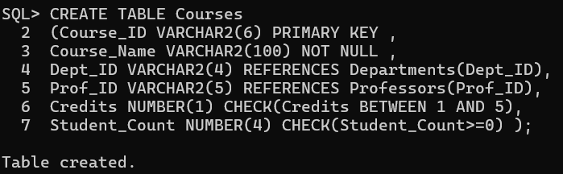

Table Name: Students
Column Name | Data Type | Constraints
Student_ID | VARCHAR2(6) | PRIMARY KEY, starts with 'S'
Student_Name | VARCHAR2(50) | NOT NULL
Dept_ID | VARCHAR2(4) | FOREIGN KEY REFERENCES Departments(Dept_ID)
DOB | DATE
CODE:
CREATE TABLE Students
(Student_ID VARCHAR2(6) PRIMARY KEY CHECK(Student_ID LIKE 'S%'),
Student_Name VARCHAR2(50) NOT NULL ,
Dept_ID VARCHAR2(4) REFERENCES Departments(Dept_ID),
DOB DATE );
OUTPUT: 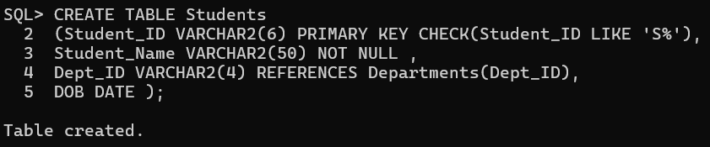

Table Name: Enrollments
Column Name | Data Type | Constraints
Student_ID | VARCHAR2(6) | FOREIGN KEY REFERENCES Students(Student_ID)
Course_ID | VARCHAR2(6) | FOREIGN KEY REFERENCES Courses(Course_ID)
Semester | VARCHAR2(6) | e.g., 'Sem1', 'Sem2'
Marks | NUMBER(5,2) | CHECK (MARKS >= 0 AND MARKS < 100)
PRIMARY KEY | (Student_ID, Course_ID)
CODE:
CREATE TABLE Enrollments
(Student_ID VARCHAR2(6) REFERENCES Students(Student_ID),
Course_ID VARCHAR2(6) REFERENCES Courses(Course_ID),
Semester VARCHAR2(6) CHECK(Semester LIKE 'Sem%'),
Marks NUMBER(5,2) CHECK(Marks >= 0 AND Marks < 100),
PRIMARY KEY (Student_ID,Course_ID) );
OUTPUT:
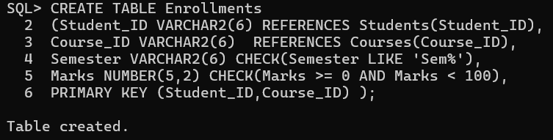

2. Add a column Dept_Head (varchar2(50)) to Departments.
CODE:
ALTER TABLE Departments
ADD Dept_Head VARCHAR2(50);

OUTPUT:
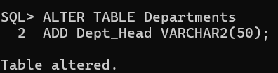
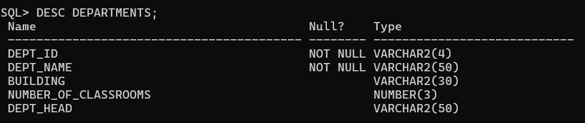

3. Change size of Experience_Years in Professors to NUMBER(3).
CODE:
ALTER TABLE Professors
MODIFY(Experience_Years NUMBER(3) );
OUTPUT:
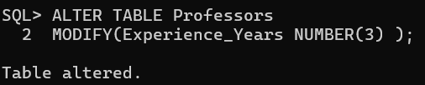
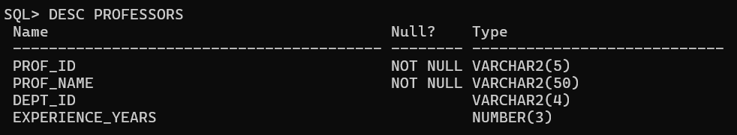

4. Rename Student_Count to Total_Students in Courses.
CODE:
ALTER TABLE Courses
RENAME COLUMN Student_Count TO Total_Students;
OUTPUT:
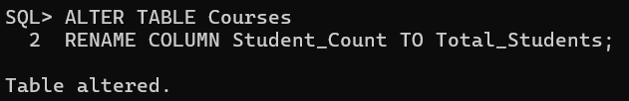
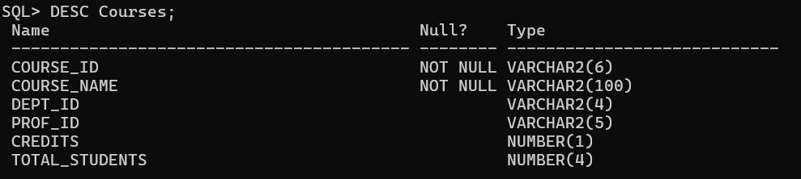

5. Drop and recreate the Enrollments table.
CODE:
DROP TABLE Enrollments;
CREATE TABLE Enrollments
(Student_ID VARCHAR2(6) REFERENCES Students(Student_ID),
Course_ID VARCHAR2(6) REFERENCES Courses(Course_ID),
Semester VARCHAR2(6) CHECK(Semester LIKE 'Sem%'),
Marks NUMBER(5,2) CHECK(Marks >= 0 AND Marks < 100),
PRIMARY KEY (Student_ID,Course_ID) );
OUTPUT:
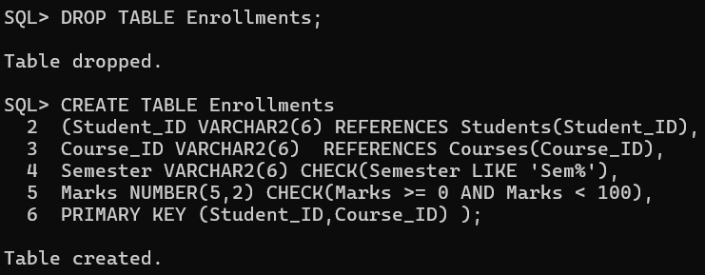

4. Practice SQL Data Manipulation Language (DML) Commands
4.1 Insertion, Deletion, Update
1. Insert the sample data into all five tables.
Departments:
Dept_ID | Dept_Name | Building | Number_of_Classrooms
D01 | Computer Science | Tech Block | 10
D02 | Electrical Engg. | Power House | 8
D03 | Mechanical Engg. | Mech Block | 6
CODE:
INSERT INTO Departments VALUES('D01','Computer Science','Tech Block',10,NULL);
INSERT INTO Departments VALUES('D02', 'Electrical Engg.','Power House',8,NULL);
INSERT INTO Departments VALUES('D03', 'Mechanical Engg.','Mech Block',6,NULL);
OUTPUT:
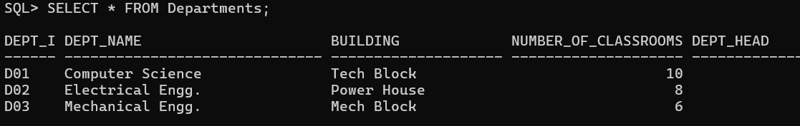

Professors:
Prof_ID | Prof_Name | Dept_ID | Experience_Years
P1001 | Dr. Meera Nair | D01 | 12
P1002 | Dr. Arjun Rao | D02 | 9
P1003 | Dr. Kavita Singh | D01 | 7
P1004 | Dr. Raj Malhotra | D03 | 15
CODE:
INSERT INTO Professors VALUES('P1001', 'Dr. Meera Nair','D01',12);
INSERT INTO Professors VALUES('P1002', 'Dr. Arjun Rao','D02',9);
INSERT INTO Professors VALUES('P1003', 'Dr. Kavita Singh','D01,7);
INSERT INTO Professors VALUES('P1004', 'Dr. Raj Malhotra','D03',15);
OUTPUT:
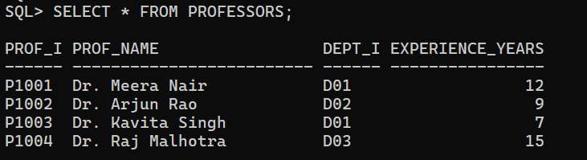

Courses:
Course_ID | Course_Name | Dept_ID | Prof_ID | Credits | Student_Count
CSE101 | Data Structures | D01 | P1001 | 4 | 2
CSE201 | Operating Systems | D01 | P1003 | 3 | 1
EEE101 | Circuit Theory | D02 | P1002 | 4 | 1
ME101 | Thermodynamics | D03 | P1004 | 3 | 1
CODE:
INSERT INTO Courses VALUES('CSE101','Data Structures','D01', 'P1001',4,2);
INSERT INTO Courses VALUES('CSE201','Operating Systems','D01', 'P1003',3,1);
INSERT INTO Courses VALUES('EEE101','Circuit Theory','D02', 'P1002',4,1);
INSERT INTO Courses VALUES('ME101','Thermodynamics','D03', 'P1004',3,1);
OUTPUT:
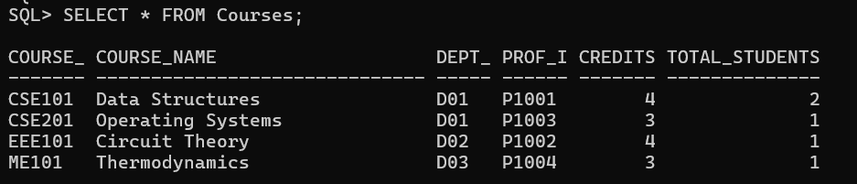

Students:
Student_ID | Student_Name | Dept_ID | DOB
S0001 | Anjali Sharma | D01 | 2003-05-14
S0002 | Ravi Kumar | D02 | 2002-11-20
S0003 | Nisha Verma | D03 | 2003-02-02
S0004 | Aman Sheikh | D01 | 2002-07-25
CODE:
INSERT INTO Students VALUES('S0001','Anjali Sharma','D01',TO_DATE('2003-05-14', 'YYYY-MM-DD'));
INSERT INTO Students VALUES('S0002',' Ravi Kumar','D02',TO_DATE('2002-11-20', 'YYYY-MM-DD'));
INSERT INTO Students VALUES('S0003',' Nisha Verma','D03',TO_DATE('2003-02-02', 'YYYY-MM-DD'));
INSERT INTO Students VALUES('S0004','Aman Sheikh','D01',TO_DATE('2002-07-25', 'YYYY-MM-DD'));
OUTPUT:
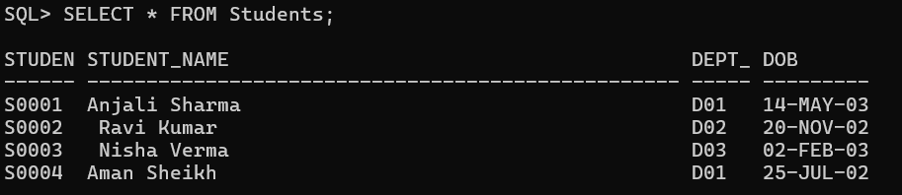

Enrollments:
Student_ID | Course_ID | Semester | Marks
S0001 | CSE101 | Sem1 | 88.0
S0001 | CSE201 | Sem2 | 76.5
S0002 | EEE101 | Sem1 | 81.0
S0003 | ME101 | Sem1 | 93.0
S0004 | CSE101 | Sem1 | 68.5
CODE:
INSERT INTO Enrollments VALUES('S0001','CSE101','Sem1',88.0);
INSERT INTO Enrollments VALUES('S0001','CSE201','Sem2',76.5);
INSERT INTO Enrollments VALUES('S0002','EEE101','Sem1',81.0);
INSERT INTO Enrollments VALUES('S0003','ME101','Sem1',93.0);
INSERT INTO Enrollments VALUES('S0004','CSE101','Sem1',68.5);
OUTPUT:
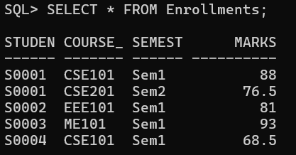

2. Insert a new department: (‘D04’, ‘Civil Engg’, ‘Block C’, 5).
CODE:
INSERT INTO Departments VALUES ('D04', 'Civil Engg', 'Block C', 5,NULL);
OUTPUT:
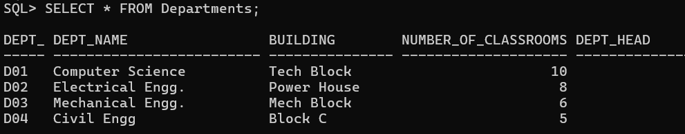

3. Create a new table high_achievers containing students who scored more than 85 in any course.
CODE:
CREATE TABLE high_achievers AS
SELECT Student_Name FROM Students
WHERE Student_ID IN
(SELECT Student_ID FROM Enrollments
WHERE marks>85);
OUTPUT:
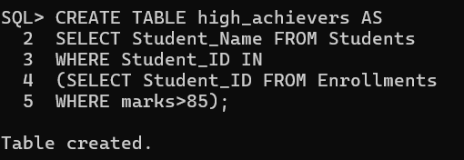

4. Create a backup table Courses_Backup with all data from Courses and Professors_Backup with all the data from professors.
CODE:
CREATE TABLE Courses_Backup AS SELECT * FROM Courses;
CREATE TABLE Professors_Backup AS SELECT * FROM Professors;
OUTPUT:
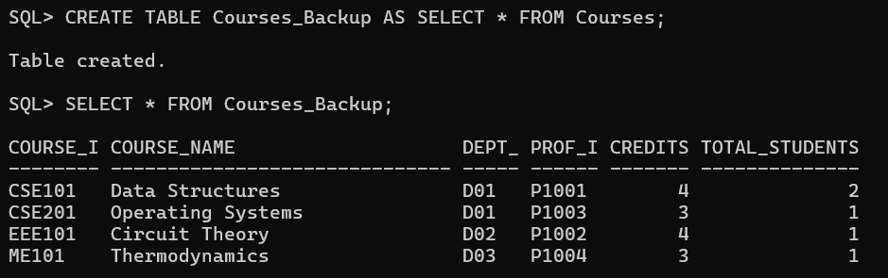
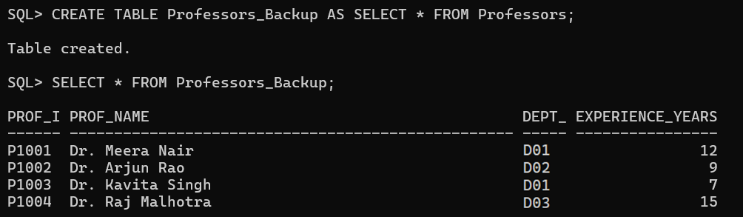

5. Add a new course ‘CIV101’, ‘Structural Analysis’, under D04, taught by P1001, with 3 credits and 0 students.
CODE:
INSERT INTO Courses VALUES('CIV101','Structural Analysis','D04', 'P1001',3,0);
OUTPUT:
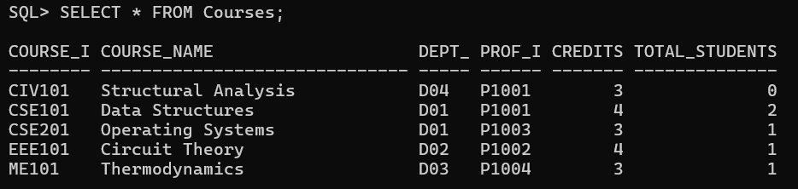

6. Update professor of ‘CIV101’ to P1004 and savepoint SP1.
CODE:
UPDATE Courses SET Prof_ID = 'P1004' WHERE Course_ID = 'CIV101';
SAVEPOINT SP1;
OUTPUT:
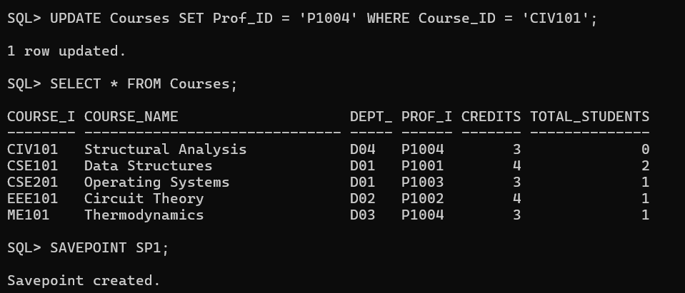

7. Change credits of ‘CSE201’ to 4 and set savepoint SP2.
CODE:
UPDATE Courses SET Credits = 4 WHERE Course_ID = 'CSE201';
SAVEPOINT SP2;
OUTPUT:
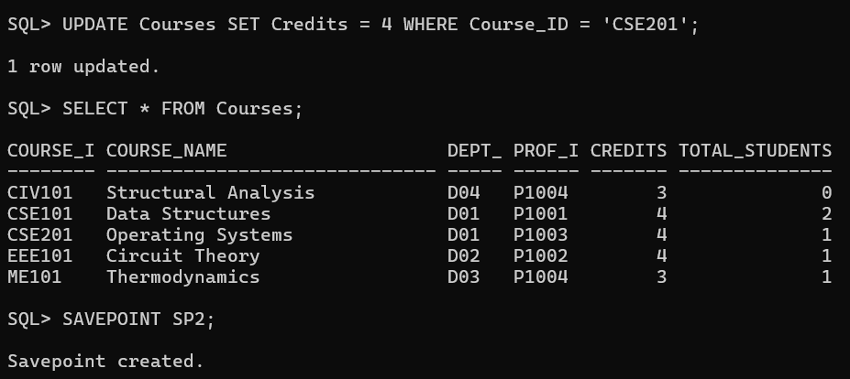

8. Delete all courses from Courses_Backup that have less than 4 credits.
CODE:
DELETE FROM Courses_Backup WHERE Credits < 4;
OUTPUT:
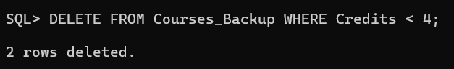

9. Delete all professors from Professors_Backup with less than 10 years experience.
CODE:
DELETE FROM Professors_Backup WHERE Experience_Years < 10;
OUTPUT:

10. Rollback to SP1 and rename Courses_Backup to Course_Master.
CODE:
ROLLBACK TO SP1;
ALTER TABLE Course_Backup RENAME TO Course_Master;
OUTPUT:
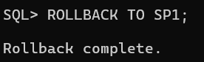
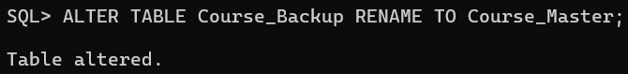

4.2 Data Retrieval (SELECT)
1. List all department names.
CODE:
SELECT Dept_Name FROM Departments;
OUTPUT:
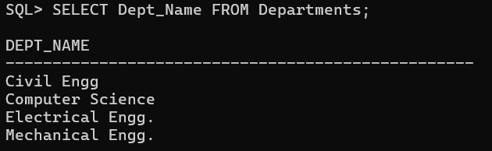

2. Display all data from the Professors table.
CODE:
SELECT * FROM Professors;
OUTPUT:

3. List student names and DOBs.
CODE:
SELECT Student_Name, DOB FROM Students;
OUTPUT:
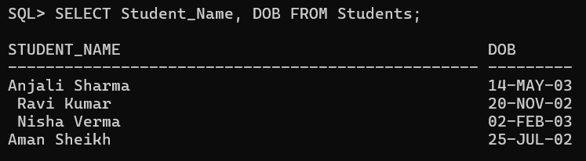

4. List course names and credits.
CODE:
SELECT Course_Name, Credits FROM Courses;
OUTPUT:
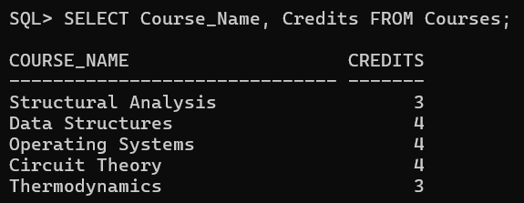

5. Get courses offered by the ‘Computer Science’ department.
CODE:
SELECT * FROM Courses WHERE Dept_ID IN
(SELECT Dept_ID FROM Departments WHERE Dept_Name = 'Computer Science');
OUTPUT:
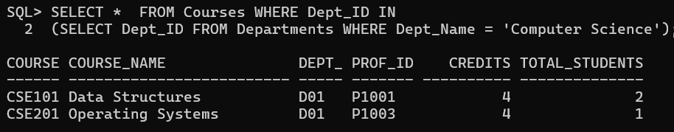

6. List professors whose name starts with ‘Dr’.
CODE:
SELECT * FROM Professors WHERE Prof_Name LIKE 'Dr%';
OUTPUT:
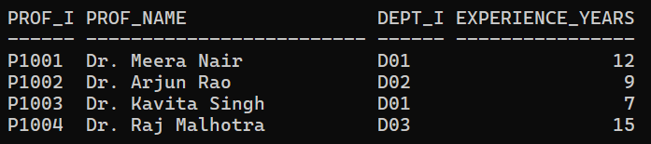

7. List courses with credits more than 3.
CODE:
SELECT * FROM Courses WHERE Credits > 3;
OUTPUT:
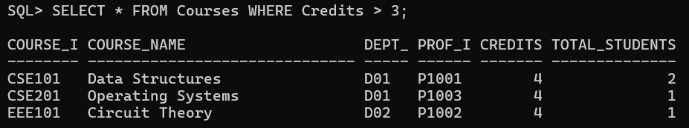

8. Display all courses with “Theory” in their name.
CODE:
SELECT * FROM Courses WHERE Course_Name LIKE '%Theory%';
OUTPUT:
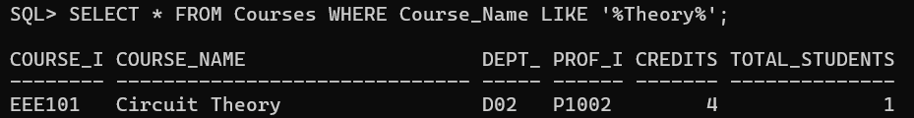

9. List students born after Jan 1, 2003.
CODE:
SELECT * FROM Students WHERE DOB > TO_DATE('01-01-2003', 'DD-MM-YYYY');
OUTPUT:
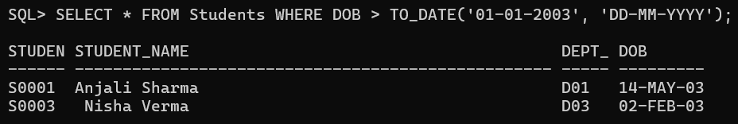

10. Find all professors with 10+ years experience.
CODE:
SELECT * FROM Professors WHERE Experience_Years >= 10;
OUTPUT:
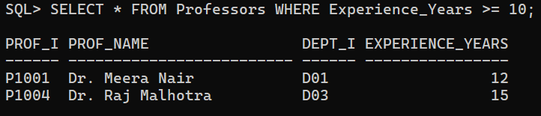

11. List all courses with more than 1 student.
CODE:
SELECT * FROM Courses WHERE Total_Students > 1;
OUTPUT:
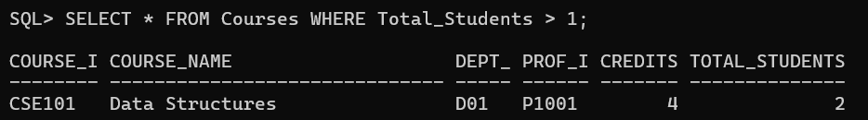

12. Display all distinct semesters from Enrollments.
CODE:
SELECT DISTINCT Semester FROM Enrollments;
OUTPUT:
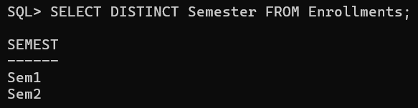

13. Show information of students with ID S0001, S0002.
CODE:
SELECT * FROM Students WHERE Student_ID IN ('S0001', 'S0002');
OUTPUT:
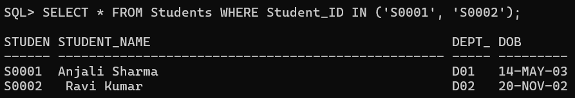

14. Show all courses not in the ‘Mechanical Engg’ department.
CODE:
SELECT * FROM Courses WHERE Dept_ID NOT IN
(SELECT Dept_ID FROM Departments WHERE Dept_Name = 'Mechanical Engg.');
OUTPUT:
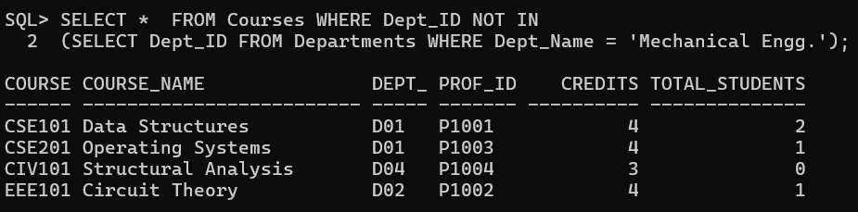

4.3 SQL Functions
1.Use numeric functions like ROUND, MOD, POWER on dummy values.
CODE:
SELECT ROUND(126.2587447, 2) FROM dual;
SELECT MOD(10, 3) FROM dual;
SELECT POWER(2, 2) FROM dual;
OUTPUT:
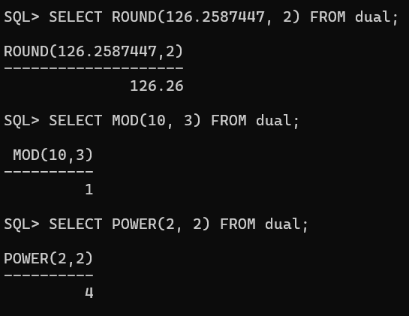

2. Use string functions like LENGTH, SUBSTR, INSTR, UPPER, LOWER on names in Professors and Students.
CODE:
For Professors:
SELECT Prof_Name,
LENGTH(Prof_Name) AS Length,
SUBSTR(Prof_Name, 1, 5) AS Substr,
INSTR(Prof_Name, 'a') AS Pos,
UPPER(Prof_Name) AS Uppercase,
LOWER(Prof_Name) AS Lowercase
FROM Professors;
For Students:
SELECT Student_Name,
LENGTH(Student_Name) AS Length,
SUBSTR(Student_Name, 1, 5) AS Substr,
INSTR(Student_Name, 'a') AS Pos,
UPPER(Student_Name) AS Uppercase,
LOWER(Student_Name) AS Lowercase
FROM Students;
OUTPUT:
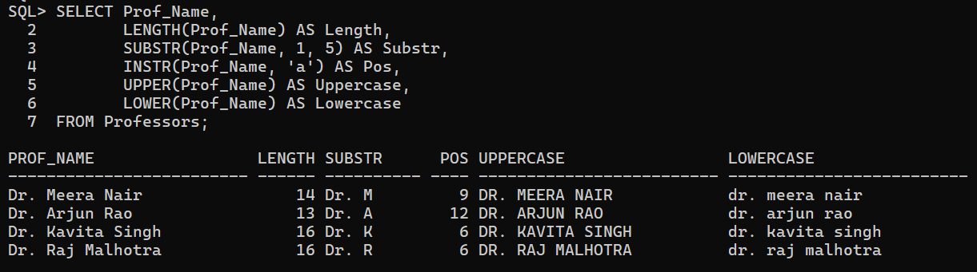
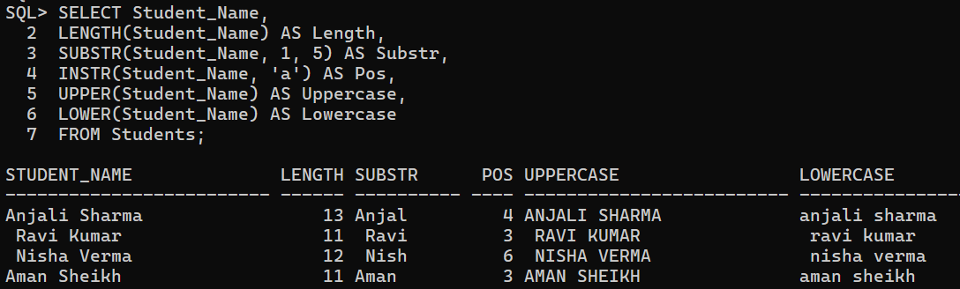

3. Use conversion functions on DOB.
CODE:
SELECT Student_ID, Student_Name, DOB,
TO_CHAR(DOB, 'DD-MM-YYYY') AS TO_CHAR,
TO_CHAR(DOB, 'Month') AS Month_Name
FROM Students;
SELECT TO_DATE('17-08-2004', 'DD-MM-YYYY') AS TO_DATE FROM DUAL;
OUTPUT:
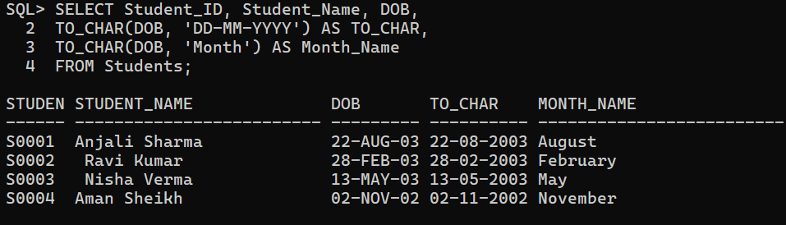
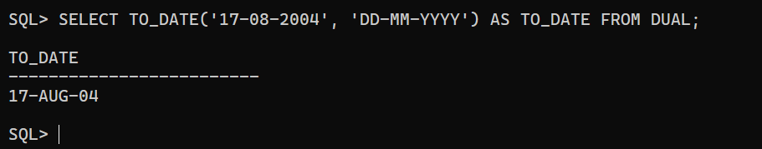

4. Count total number of students.
CODE:
SELECT COUNT(*) AS Total_Students FROM Students;
OUTPUT:
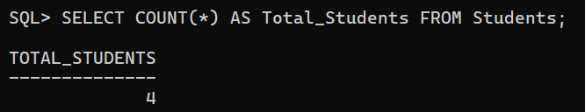

5. Find max and min marks in Enrollments as max_marks, min_marks.
CODE:
SELECT MAX(Marks) AS Max_Marks,
MIN(Marks) AS Min_Marks
FROM Enrollments;

OUTPUT:
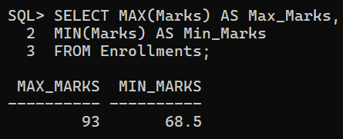

6. Count number of students with marks over 75.
CODE:
SELECT COUNT(*) AS Students_Above_75
FROM Enrollments
WHERE Marks > 75;

OUTPUT:
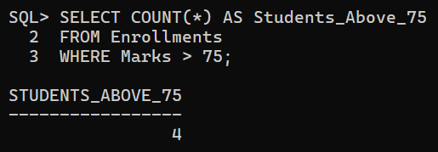

4.4 Date Functions
1. List student names and their day of birth.
CODE:
SELECT Student_Name,
TO_CHAR(DOB, 'Day') AS Day_Of_Birth
FROM Students;
OUTPUT:
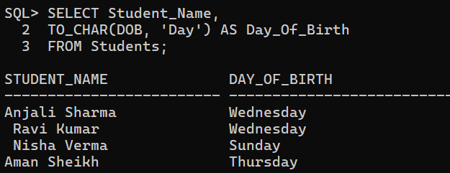

2. Format DOBs in ‘DD-Month-YYYY’ format.
CODE:
SELECT Student_Name,
TO_CHAR(DOB, 'DD-Month-YYYY') AS DOB
FROM Students;
OUTPUT:
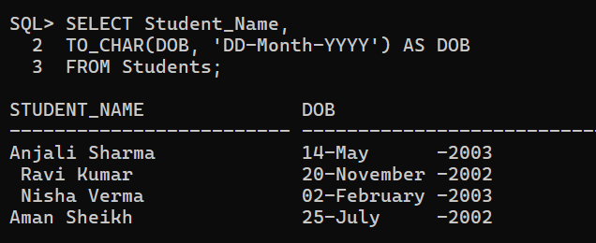
3. Show DOBs in ‘DD-MM-YY’ format.
CODE:
SELECT Student_Name,
TO_CHAR(DOB, 'DD-MM-YY') AS DOB
FROM Students;
OUTPUT:
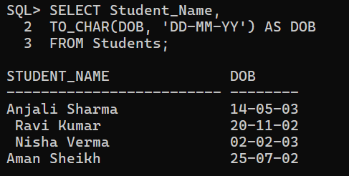

4. Add 100 days to all DOBs.
CODE:
UPDATE Students SET DOB = DOB + 100;
OUTPUT:
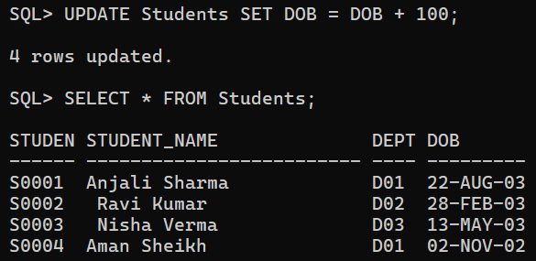

5. List students born in May.
CODE:
SELECT Student_Name, DOB
FROM Students
WHERE TO_CHAR(DOB, 'Mon') = 'May';
OUTPUT:
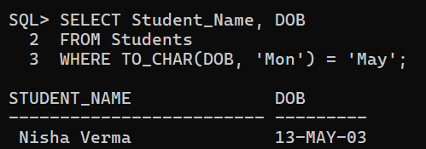

6. List students born between 2002 and 2003.
CODE:
SELECT Student_Name, DOB
FROM Students
WHERE TO_CHAR(DOB, 'yyyy') BETWEEN '2002' AND '2003';
OUTPUT:
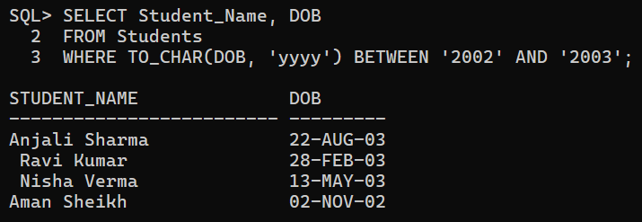

4.5 Set Operators
Create Top_Courses table:
CREATE TABLE Top_Courses (
Course_Name VARCHAR2(100),
Dept_Name VARCHAR2(50)
);
Insert some course-department pairs.
INSERT INTO Top_Courses VALUES ('Data Structures', 'Computer Science');
INSERT INTO Top_Courses VALUES ('Circuit Theory', 'Electrical Engg.');
INSERT INTO Top_Courses VALUES ('Thermodynamics', 'Mechanical Engg.');
INSERT INTO Top_Courses VALUES ('Artificial Intelligence', 'Computer Science');
INSERT INTO Top_Courses VALUES (' Concrete Technology', 'Civil Engg');

OUTPUT:
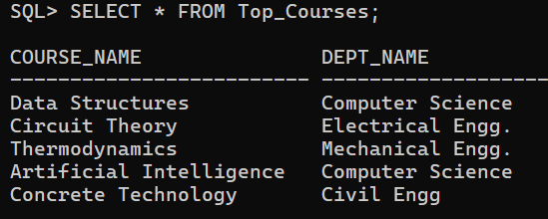

1. Show unique course names from both Courses and Top_Courses.
CODE:
SELECT Course_Name FROM Courses
UNION
SELECT Course_Name FROM Top_Courses;

OUTPUT
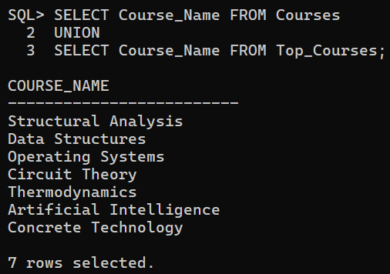

2. Show common courses between Courses and Top_Courses.
CODE:
SELECT Course_Name FROM Courses
INTERSECT
SELECT Course_Name FROM Top_Courses;
OUTPUT
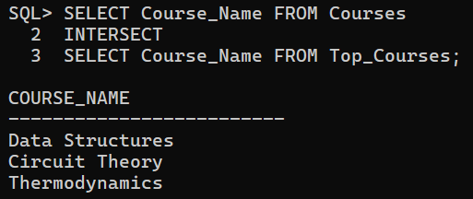

3. Show top courses that are not in current courses.
CODE:
SELECT Course_Name FROM Top_Courses
MINUS
SELECT Course_Name FROM Courses;
OUTPUT
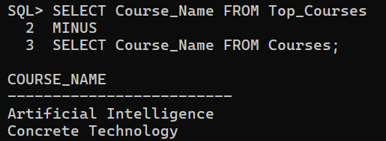

4.Show union all of both.
CODE:
SELECT Course_Name FROM Courses
UNION ALL
SELECT Course_Name FROM Top_Courses;
OUTPUT:
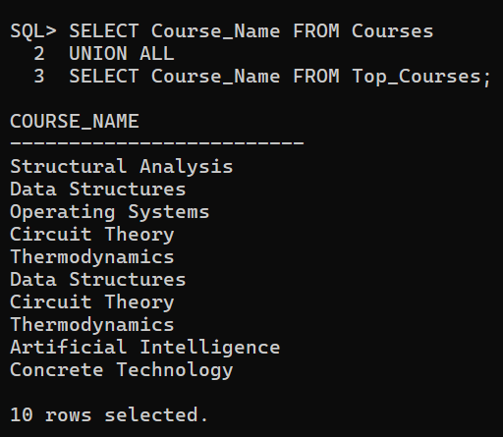
4.6 Sorting
1. Sort professors by descending experience.
CODE:
SELECT * FROM Professors
ORDER BY Experience_Years DESC;
OUTPUT:
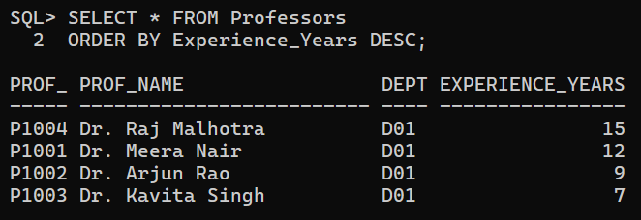

4.7 Group By, Having
1. Number of students per department (only those >1).
CODE:
SELECT Dept_Id, COUNT(Student_ID)
FROM Students
GROUP BY Dept_ID
HAVING COUNT(Student_ID) > 1;
OUTPUT:
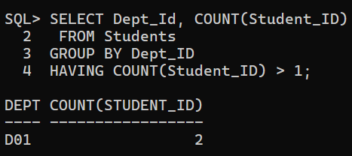

2. Departments with avg classroom count >5.
CODE:
SELECT Dept_Name, AVG(Number_of_Classrooms) AS AVG_CLASSROOMS
FROM Departments
GROUP BY Dept_Name
HAVING AVG(Number_of_Classrooms) > 5;
OUTPUT:
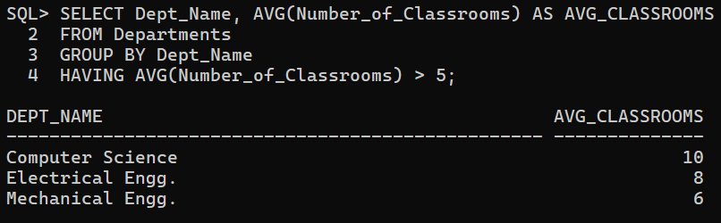
3. Courses taught by professors with more than 1 course.
CODE:
SELECT c.Course_Name, p.Prof_Name
FROM Courses c, Professors p
WHERE c.Prof_ID = p.Prof_ID
AND c.Prof_ID IN (
SELECT Prof_ID FROM Courses
GROUP BY Prof_ID
HAVING COUNT(Course_ID) > 1 );
OUTPUT:
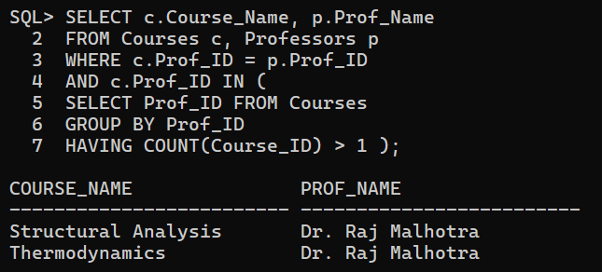
4.8 Subqueries
1. Find names of students enrolled in any course.
CODE:
SELECT Student_Name
FROM Students
WHERE Student_ID IN
(SELECT Student_ID
FROM enrollments);
OUTPUT:
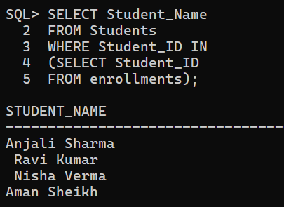

2. Find department of student S0001.
CODE:
SELECT Dept_ID, Dept_Name
FROM Departments
WHERE Dept_ID =
(SELECT Dept_ID
FROM Students
WHERE Student_ID = 'S0001');

OUTPUT:
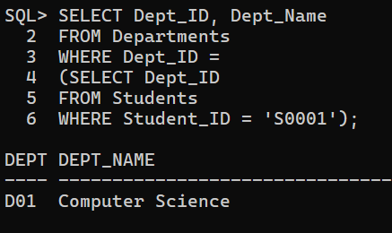

3. Departments where student count > 1.
CODE:
SELECT Dept_ID, Dept_Name
FROM Departments
WHERE Dept_ID IN
(SELECT Dept_ID
FROM Students
GROUP BY Dept_ID
HAVING COUNT(*) > 1 ) ;
OUTPUT:
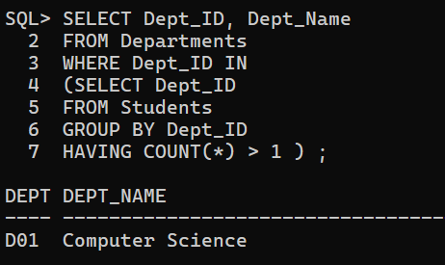
4. List courses taught by professors with >10 years experience.
CODE:
SELECT Course_ID, Course_Name
FROM Courses
WHERE Prof_ID IN
(SELECT Prof_ID
FROM Professors
WHERE Experience_Years > 10);
OUTPUT:
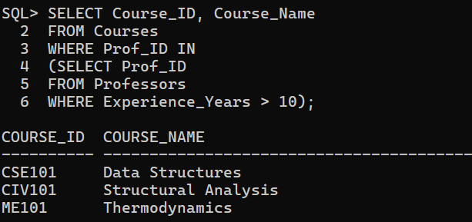

5. List students in departments with at least 1 professor.
CODE:
SELECT Student_Name
FROM Students
WHERE Dept_ID IN
(SELECT Dept_ID
FROM Professors
GROUP BY Dept_ID
HAVING COUNT(*) >= 1 );

OUTPUT:
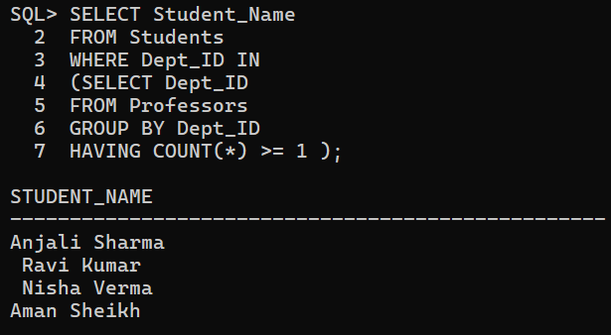

6. Find the professors with exp less than the average experience of all the professors.
CODE:
SELECT Prof_Name
FROM Professors
WHERE Experience_Years <
(SELECT AVG(Experience_Years)
FROM Professors );
OUTPUT:
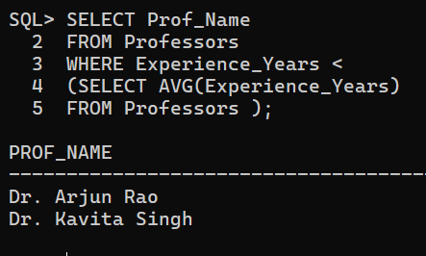

4.9 NOT EXISTS
1. Departments where every professor has > 5 years experience.
CODE:
SELECT D.Dept_Name, D.Dept_ID
FROM Departments D
WHERE NOT EXISTS
(SELECT P.Dept_ID
FROM Professors P
WHERE P.Dept_ID = D.Dept_ID
AND P. Experience_Years <=5 );
OUTPUT:
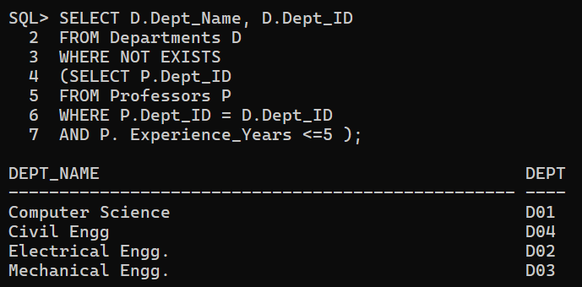

2. Departments with no students.
CODE:
SELECT D.Dept_Name, D.Dept_ID
FROM Departments D
WHERE NOT EXISTS
(SELECT Dept_ID
FROM Students S
WHERE S.Dept_ID = D.Dept_ID );
OUTPUT:
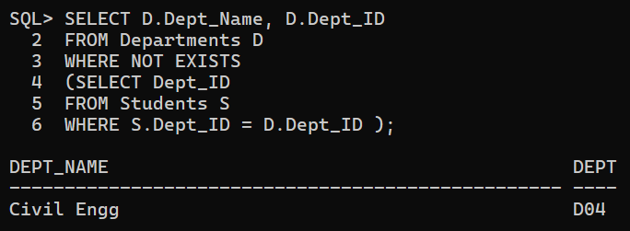

4.10 Correlated Subqueries
1. Students with marks above average.
CODE:
SELECT S.Student_Name, E.Course_ID, E.Marks
FROM Students S, Enrollments E
WHERE S.Student_ID = E.Student_ID
AND E.Marks > (
SELECT AVG(E2.Marks)
FROM Enrollments E2
WHERE E2.Course_ID = E.Course_ID );
OUTPUT:
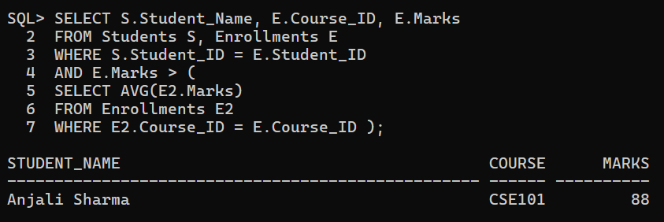

2. Students with DOB later than any student from 'Electrical Engg'.
CODE:
SELECT S.Student_Name, S.DOB
FROM Students S
WHERE EXISTS (
SELECT *
FROM Students S2
WHERE S2.Dept_ID = 'D02'
AND S.DOB > S2.DOB );

OUTPUT:
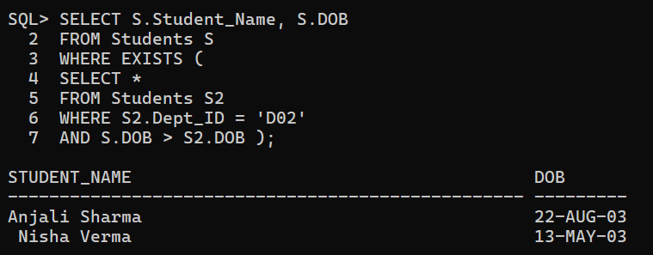

4.11 JOINING Tables
1. List student names along with their department name.
CODE:
SELECT S.Student_Name, D.Dept_Name
FROM Students S
INNER JOIN Departments D ON S.Dept_ID = D.Dept_ID;
OUTPUT:
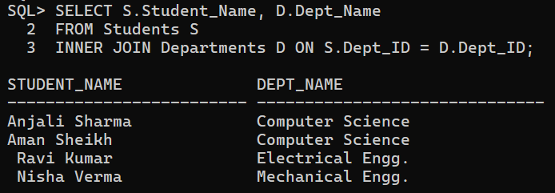
2. Courses and number of students enrolled.
CODE:
SELECT C.Course_ID, C.Course_Name, COUNT(E. Student_ID) AS COUNT
FROM Courses C
LEFT JOIN Enrollments E
ON C.Course_ID = E.Course_ID
GROUP BY C.Course_ID, C.Course_Name ;
OUTPUT:
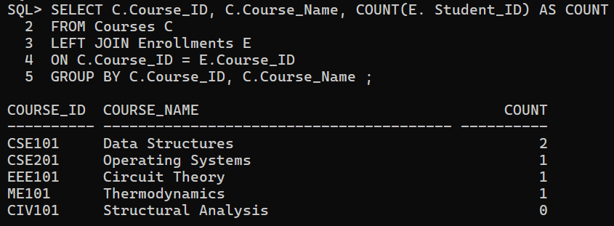
3. List course name and professor name.
CODE:
SELECT C.Course_ID, C.Course_Name, P.Prof_Name
FROM Courses C
INNER JOIN Professors P
ON C. Prof_ID = P. Prof_ID ;
OUTPUT:
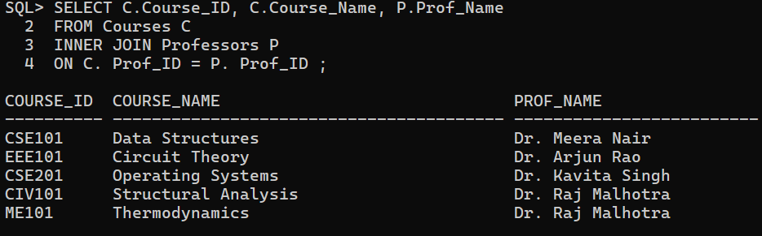

4. Departments with more than one professor.
CODE:
SELECT D.Dept_Name, COUNT(P.Prof_ID) AS Total_Professors
FROM Departments D
INNER JOIN Professors P
ON D.Dept_ID = P.Dept_ID
GROUP BY D.Dept_ID, D.Dept_Name
HAVING COUNT(P.Prof_ID) > 1;
OUTPUT:
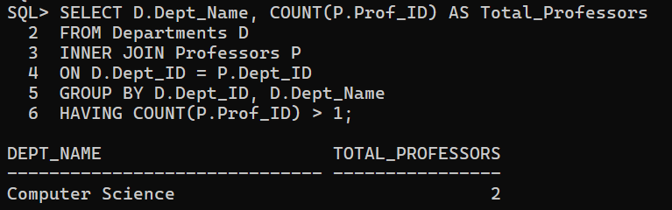
5. List students enrolled in courses with more than 3 credits.
CODE:
SELECT S.Student_ID, S.Student_Name, C.Course_ID, C.Credits
FROM Students S
INNER JOIN Enrollments E ON S.Student_ID = E.Student_ID
INNER JOIN Courses C ON E.Course_ID = C.Course_ID
WHERE C.Credits > 3;
OUTPUT:
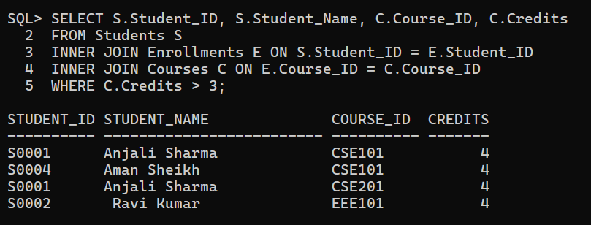

5. PL/SQL Section
5.1 Basic Blocks
1. Accept a course ID and show number of students enrolled.
CODE:
SET SERVEROUTPUT ON;
DECLARE
v_course_id Courses.Course_ID%TYPE;
v_student_count NUMBER;
BEGIN
v_course_id := '&course_id';
SELECT COUNT(*)
INTO v_student_count
FROM Enrollments
WHERE Course_ID = v_course_id;
DBMS_OUTPUT.PUT_LINE('Number of students enrolled in ' || v_course_id || ': ' || v_student_count);
END;
/
OUTPUT:
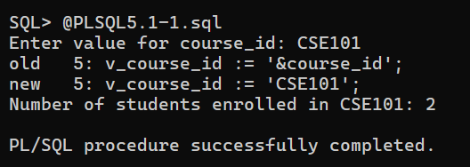

2. If department 'Biotech' doesn't exist, insert it with ‘D05’.
CODE:
SET SERVEROUTPUT ON;
DECLARE
v_count NUMBER;
BEGIN
SELECT COUNT(*)
INTO v_count
FROM Departments
WHERE Dept_Name = 'Biotech';

IF v_count = 0 THEN
INSERT INTO Departments (Dept_ID, Dept_Name, Building, Number_of_Classrooms)
VALUES ('D05', 'Biotech', 'Bio Block', 5);
DBMS_OUTPUT.PUT_LINE('Department Biotech inserted.');
ELSE
DBMS_OUTPUT.PUT_LINE('Department Biotech already exists.');
END IF;
END;
/
OUTPUT:
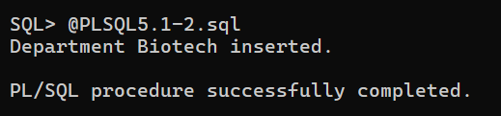

3. Calculate total students in ‘Computer Science’.
CODE:
SET SERVEROUTPUT ON;
DECLARE
v_count NUMBER;
BEGIN
SELECT COUNT(*)
INTO v_count
FROM Departments
WHERE Dept_Name = 'Biotech';

IF v_count = 0 THEN
INSERT INTO Departments (Dept_ID, Dept_Name, Building, Number_of_Classrooms)
VALUES ('D05', 'Biotech', 'Bio Block', 5);
DBMS_OUTPUT.PUT_LINE('Department Biotech inserted.');
ELSE
DBMS_OUTPUT.PUT_LINE('Department Biotech already exists.');
END IF;
END;
/
OUTPUT:
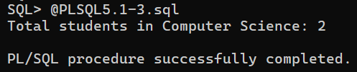

5.2 Cursors
1. Insert a new student and show row count.
CODE:
SET SERVEROUTPUT ON;
DECLARE
v_rows NUMBER;
BEGIN
INSERT INTO Students (Student_ID, Student_Name, Dept_ID, DOB)
VALUES ('S0005', 'Rahul Dev', 'D02', DATE '2003-09-15');
v_rows := SQL%ROWCOUNT;
DBMS_OUTPUT.PUT_LINE('Rows inserted: ' || v_rows);
END;
/
OUTPUT:
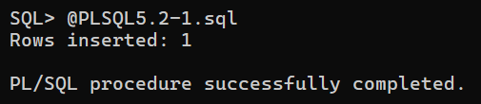

2. Update marks and show affected row count.
CODE:
SET SERVEROUTPUT ON;
DECLARE
v_rows NUMBER;
BEGIN
UPDATE Enrollments
SET Marks = Marks + 2
WHERE Semester = 'Sem1';
v_rows := SQL%ROWCOUNT;
DBMS_OUTPUT.PUT_LINE('Marks updated for ' || v_rows || ' students.');
END;
/
OUTPUT:
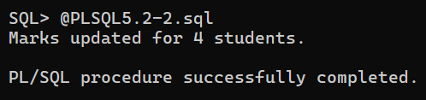

3. List students with marks above 80 (Explicit Cursor).
CODE:
SET SERVEROUTPUT ON;
DECLARE
CURSOR c1 IS
SELECT s.Student_Name, e.Marks
FROM Students s, Enrollments e
WHERE s.Student_ID = e.Student_ID
AND e.Marks > 80;
BEGIN
FOR rec IN c1
LOOP
DBMS_OUTPUT.PUT_LINE(rec.Student_Name || ' scored ' || rec.Marks);
END LOOP;
END;
/

OUTPUT:
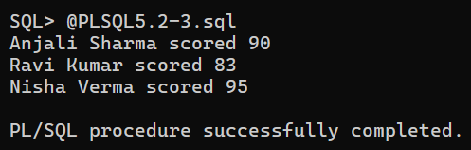

4. List all courses taught by P1001 (Explicit Cursor).
CODE:
SET SERVEROUTPUT ON;
DECLARE
CURSOR c1 IS
SELECT Course_Name
FROM Courses
WHERE Prof_ID = 'P1001';
BEGIN
FOR rec IN c1
LOOP
DBMS_OUTPUT.PUT_LINE('Course: ' || rec.Course_Name);
END LOOP;
END;
/
OUTPUT:
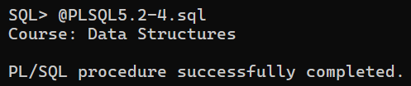
5.3 Procedures
1. Procedure: Accept student ID and return number of enrolled courses.
CODE:
SET SERVEROUTPUT ON;
CREATE OR REPLACE PROCEDURE student_course_count(
p_student_id IN VARCHAR2
) AS
v_count NUMBER;
BEGIN
SELECT COUNT(*)
INTO v_count
FROM Enrollments
WHERE Student_ID = p_student_id;

DBMS_OUTPUT.PUT_LINE('Student ' || p_student_id || ' is enrolled in ' || v_count || ' courses.');
END;
/
BEGIN
student_course_count('&student_id');
END;
/
OUTPUT:
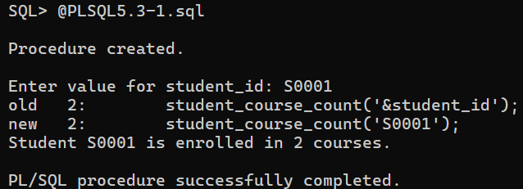
2. Procedure: Insert new course if department and professor exist.
CODE:
SET SERVEROUTPUT ON;
CREATE OR REPLACE PROCEDURE add_course(
p_course_id IN VARCHAR2,
p_course_name IN VARCHAR2,
p_dept_id IN VARCHAR2,
p_prof_id IN VARCHAR2,
p_credits IN NUMBER
) AS
v_dept NUMBER;
v_prof NUMBER;
BEGIN
-- Check if department exists
SELECT COUNT(*) INTO v_dept FROM Departments WHERE Dept_ID = p_dept_id;
-- Check if professor exists
SELECT COUNT(*) INTO v_prof FROM Professors WHERE Prof_ID = p_prof_id;
IF v_dept > 0 AND v_prof > 0 THEN
INSERT INTO Courses (Course_ID, Course_Name, Dept_ID, Prof_ID, Credits, Total_Students)
VALUES (p_course_id, p_course_name, p_dept_id, p_prof_id, p_credits, 0);
DBMS_OUTPUT.PUT_LINE('Course ' || p_course_name || ' added successfully.');
ELSE
DBMS_OUTPUT.PUT_LINE('Department or Professor not found. Cannot add course.');
END IF;
END;
/
BEGIN
add_course('CIV102', 'Concrete Design', 'D04', 'P1004', 3);
END;
/
OUTPUT:
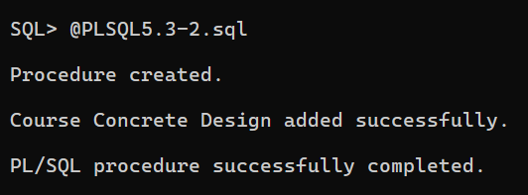

3. Procedure: Update course credits and log to new table.
CODE:
SET SERVEROUTPUT ON;
CREATE TABLE Course_Log (
Course_ID VARCHAR2(6),
Old_Credits NUMBER(1),
New_Credits NUMBER(1),
Update_Date DATE
);
CREATE OR REPLACE PROCEDURE update_course_credits(
p_course_id IN VARCHAR2,
p_new_credits IN NUMBER
) AS
v_old NUMBER;
BEGIN
SELECT Credits INTO v_old FROM Courses WHERE Course_ID = p_course_id;
UPDATE Courses
SET Credits = p_new_credits
WHERE Course_ID = p_course_id;
INSERT INTO Course_Log VALUES (p_course_id, v_old, p_new_credits, SYSDATE);
DBMS_OUTPUT.PUT_LINE('Credits updated and logged for ' || p_course_id);
END;
/
BEGIN
update_course_credits('ME101', 4);
END;
/
OUTPUT:
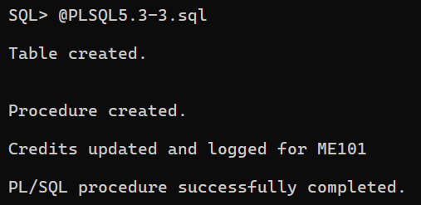

5.4 Functions
1. Function to return age of student.
CODE:
SET SERVEROUTPUT ON;
CREATE OR REPLACE FUNCTION get_student_age(p_student_id IN VARCHAR2)
RETURN NUMBER
AS
v_age NUMBER;
v_dob DATE;
BEGIN
-- Get DOB from table
SELECT DOB INTO v_dob
FROM Students
WHERE Student_ID = p_student_id;
-- Calculate age
v_age := TRUNC(MONTHS_BETWEEN(SYSDATE, v_dob)/12);
RETURN v_age;
END;
/
BEGIN
DBMS_OUTPUT.PUT_LINE('Age: ' || get_student_age('&student_id'));
END;
/
OUTPUT:
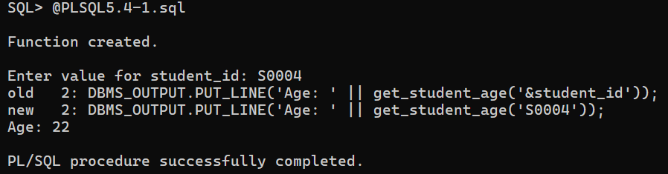
2. Function to count courses offered by a department.
CODE:
SET SERVEROUTPUT ON;
CREATE OR REPLACE FUNCTION count_courses_by_dept(p_dept_id IN VARCHAR2)
RETURN NUMBER
AS
v_count NUMBER;
BEGIN
SELECT COUNT(*)
INTO v_count
FROM Courses
WHERE Dept_ID = p_dept_id;
RETURN v_count;
END;
/
BEGIN
DBMS_OUTPUT.PUT_LINE('Total courses in department: ' || count_courses_by_dept('&dept_id'));
END;
/
OUTPUT:
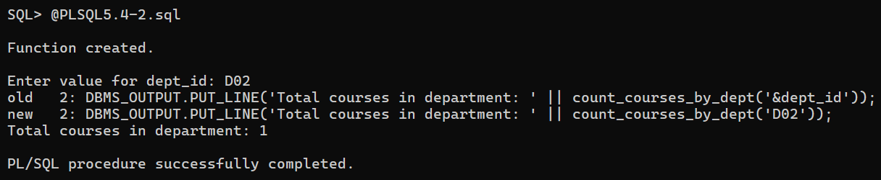

3. Function to check if a professor teaches more than 2 courses.
CODE:
SET SERVEROUTPUT ON;
CREATE OR REPLACE FUNCTION teaches_more_than_two(p_prof_id IN VARCHAR2)
RETURN VARCHAR2
AS
v_count NUMBER;
BEGIN
SELECT COUNT(*)
INTO v_count
FROM Courses
WHERE Prof_ID = p_prof_id;
IF v_count > 2 THEN
RETURN 'YES';
ELSE
RETURN 'NO';
END IF;
END;
/
BEGIN
DBMS_OUTPUT.PUT_LINE('Does professor teach >2 courses? ' || teaches_more_than_two('&pid'));
END;
/
OUTPUT:
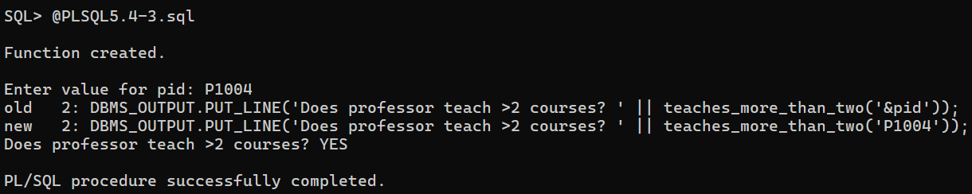
5.5 Triggers
1. Prevent deletion of courses with more than 2 credits.
CODE:
SET SERVEROUTPUT ON;
CREATE OR REPLACE TRIGGER trg_prevent_delete_course
BEFORE DELETE ON Courses
FOR EACH ROW
BEGIN
IF :OLD.Credits > 2 THEN
RAISE_APPLICATION_ERROR(-20001, 'Cannot delete course with more than 2 credits.');
END IF;
END;
/
BEGIN
DELETE from Courses where Credits>2;
END;
/
OUTPUT:
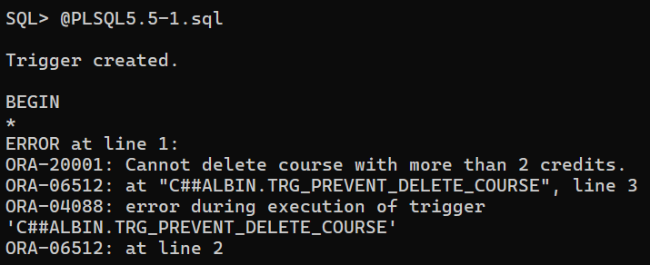

2. Log updates to Marks in Enrollments_Log.
CODE:
SET SERVEROUTPUT ON;
CREATE TABLE Enrollments_Log (
Student_ID VARCHAR2(6),
Course_ID VARCHAR2(6),
Old_Marks NUMBER(5,2),
New_Marks NUMBER(5,2),
Update_Date DATE
);
CREATE OR REPLACE TRIGGER trg_log_marks_update
AFTER UPDATE OF Marks ON Enrollments
FOR EACH ROW
BEGIN
INSERT INTO Enrollments_Log
VALUES (:OLD.Student_ID, :OLD.Course_ID, :OLD.Marks, :NEW.Marks,
SYSDATE);
END;
/
OUTPUT:
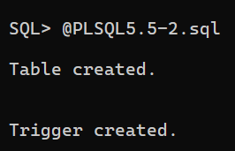

3. Prevent duplicate enrollments in a course.
CODE:
SET SERVEROUTPUT ON;
CREATE OR REPLACE TRIGGER trg_prevent_duplicate_enroll
BEFORE INSERT ON Enrollments
FOR EACH ROW
DECLARE
v_count NUMBER;
BEGIN
SELECT COUNT(*) INTO v_count
FROM Enrollments
WHERE Student_ID = :NEW.Student_ID
AND Course_ID = :NEW.Course_ID;
IF v_count > 0 THEN
RAISE_APPLICATION_ERROR(-20002, 'Student already enrolled in this course.');
END IF;
END;
/
BEGIN
INSERT INTO Enrollments (Student_ID, Course_ID, Semester, Marks)
VALUES ('S0001', 'CSE101', 'Sem1', 90);
END;
/

OUTPUT:
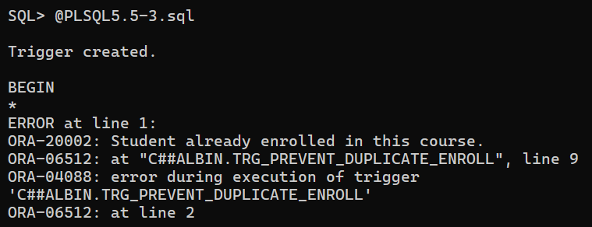

4. Prevent update / delete being done on Sunday / Saturday.
CODE:
SET SERVEROUTPUT ON;
CREATE OR REPLACE TRIGGER trg_no_weekend_changes
BEFORE UPDATE OR DELETE ON Courses
FOR EACH ROW
BEGIN
-- Check if today is Saturday or Sunday
IF TO_CHAR(SYSDATE,'D') IN ('7','1') THEN
RAISE_APPLICATION_ERROR(-20003, 'Updates or deletes not allowed on weekends.');
END IF;
END;
/
OUTPUT:
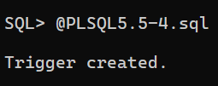

5.6 Views
1. View: Students and number of courses they are enrolled in.
CODE:
SET SERVEROUTPUT ON;
CREATE OR REPLACE VIEW Students_Course_Count AS
SELECT s.Student_ID,
s.Student_Name,
(SELECT COUNT(*)
FROM Enrollments e
WHERE e.Student_ID = s.Student_ID) AS Courses_Enrolled
FROM Students s;
SELECT * FROM Students_Course_Count;
OUTPUT:
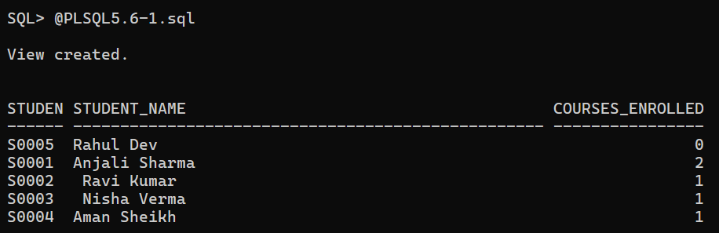

2.View: Courses and average marks of enrolled students (only for courses with >1 student).
CODE:
CREATE OR REPLACE VIEW Courses_Avg_Marks AS
SELECT c.Course_ID,
c.Course_Name,
AVG(e.Marks) AS Avg_Marks,
COUNT(e.Student_ID) AS Student_Count
FROM Courses c
JOIN Enrollments e ON c.Course_ID = e.Course_ID
GROUP BY c.Course_ID, c.Course_Name
HAVING COUNT(e.Student_ID) > 1;

SELECT * FROM Courses_Avg_Marks;
OUTPUT:
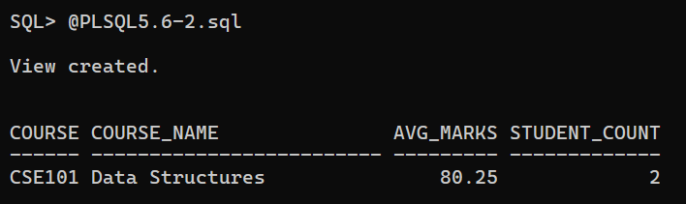

6. Project – College Admission Management System
Abstract
The College Admission Management System is a database application developed using Microsoft Access to efficiently manage student, course, and admission details in an educational institution. The system provides a structured way to store and retrieve student records, track course enrollments, and monitor fee payments. It eliminates manual record-keeping, reduces redundancy, and ensures data accuracy through proper relationships between tables.
The database consists of three main tables (Students, Courses, and Admissions) which are linked using primary and foreign keys to establish relational integrity. Various forms were created for easy data entry, including dropdown fields for selecting gender, student names, and courses. Several queries were designed to generate useful information, such as listing students with pending fees, displaying admission details, and calculating remaining fees dynamically using expressions. Additionally, reports were built to present the data neatly for printing and analysis, such as course-wise admissions and pending fee summaries.
This project demonstrates the practical use of DBMS concepts like normalization, relationships, queries, and report generation. It provides an efficient, user-friendly platform for managing student admissions and payments in small educational setups, showcasing how relational databases can automate and simplify real-world administrative tasks.

Screenshots
Tables:
1. Students:
2. Courses:
3. Admissions:

Relationships:

Forms:
1. Student Entry Form:
2. Course Entry Form:
3. Admission Form:

Queries:
Reports:

1. Installation of Oracle Database (23 ai Free)
- Visit the Oracle Home Page and download the ZIP file for the Windows x64 platform. The direct link is provided as https://www.oracle.com/in/database/free/get-started/#windows.
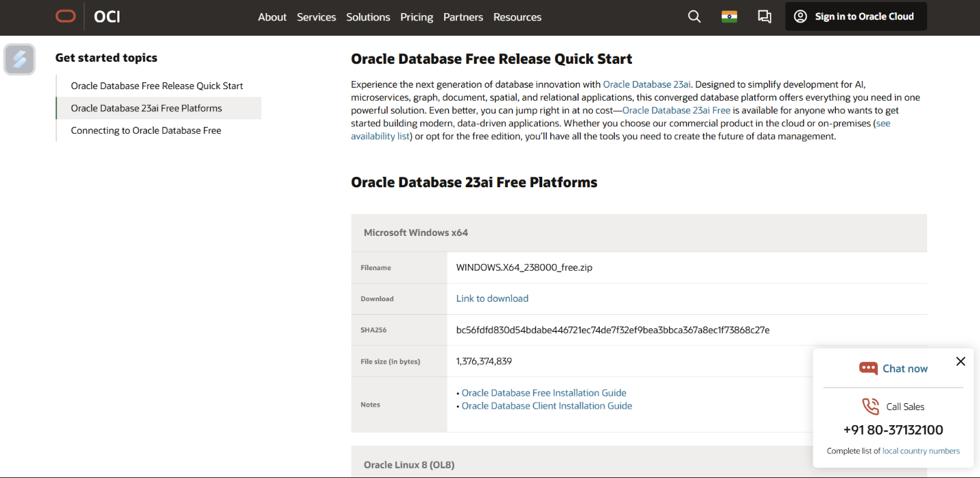

- Locate the downloaded ZIP file and extract all its contents.
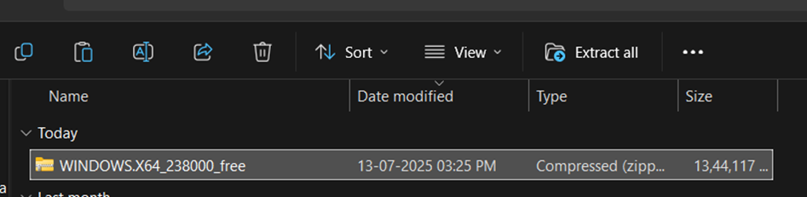

- Open the extracted folder and run the setup via Run As Administrator.
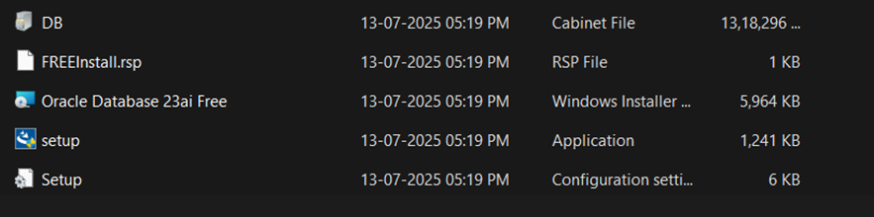

- Proceed through the InstallShield Wizard.
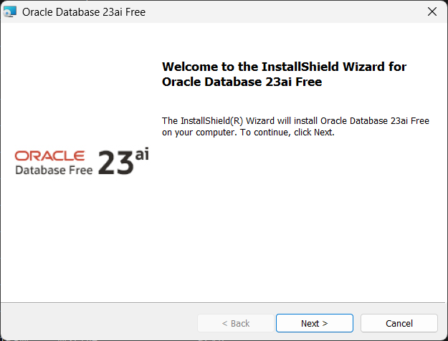

- Read the Oracle Free Use Terms and Conditions and Accept the License Agreement.
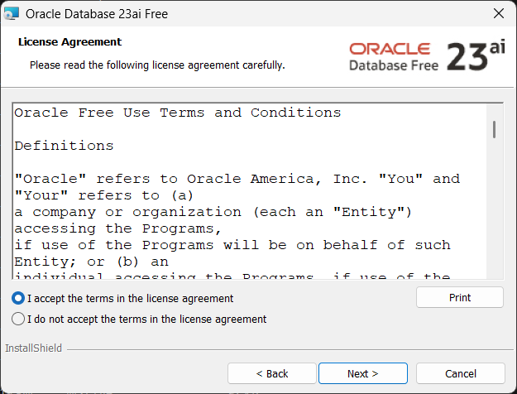

- Select Destination Folder.
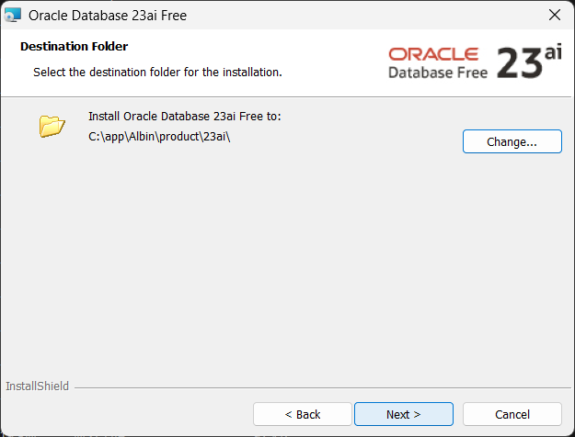
- Set Database Password.
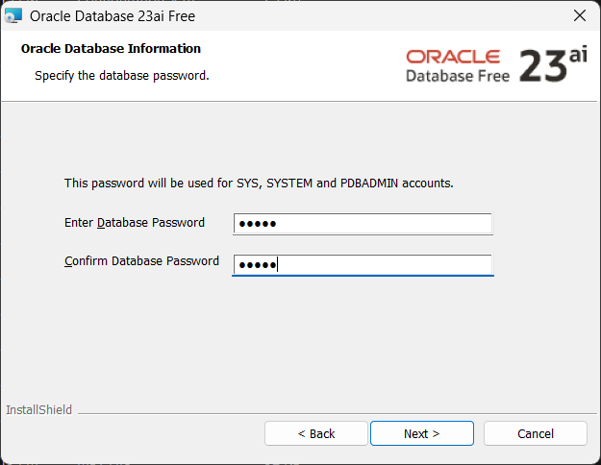

- Confirm the Details and Begin Installation.
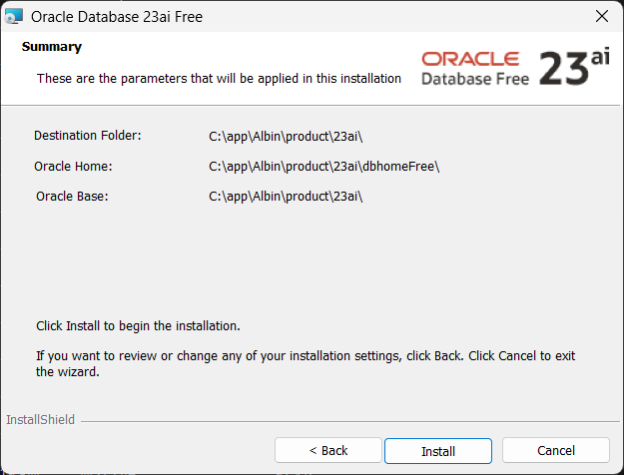

- Wait for Installation to Finish. This may take several minutes.
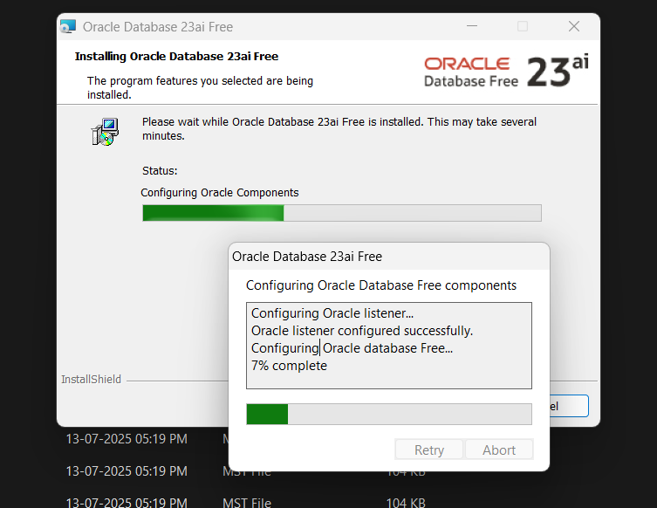
- Once installation finishes successfully, click Finish to exit the wizard.
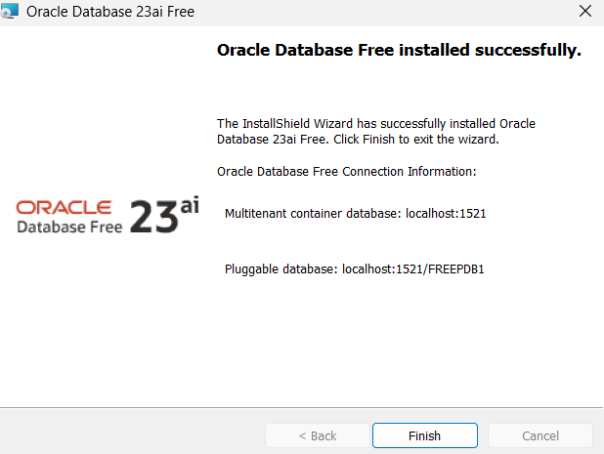

- Open the sql plus and connect to database by entering the username and password.
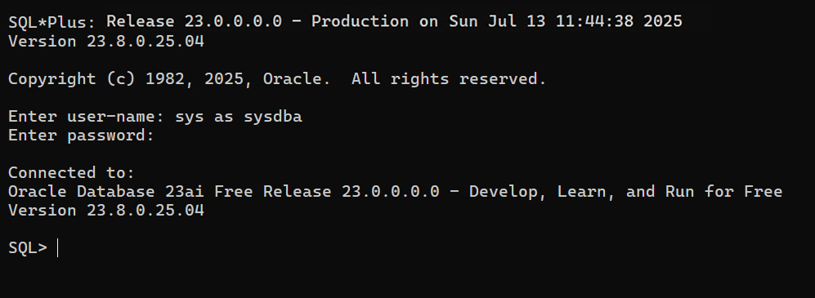

2. Entities and Relationship Diagram
